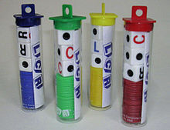
“Card & Games Night”
Friday September 22, 2017

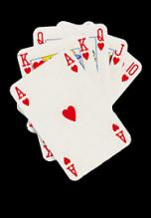
Rochester Community House
816 Ludlow St.
Rochester, 48307
7 – 10pm
$8 per person

Includes:
- Pizza

Everyone is invited to join us for a night of Cards, Games, and FUN!
When was the last time you were able to try your luck at Euchre, Pinochle or Hearts?
How about everyone’s family favorite “Left, Right, Center” game?
Come out and make a new friend!


- Soft Drinks
- Snacks
- Salad
~Playing cards supplied~
- Dessert

For more information contact:

Connie Roussin 586-601-5555 or Pat Miller 586-405-8091

B.Y.O.B. & Games to share ~ 50/50 Drawings~

